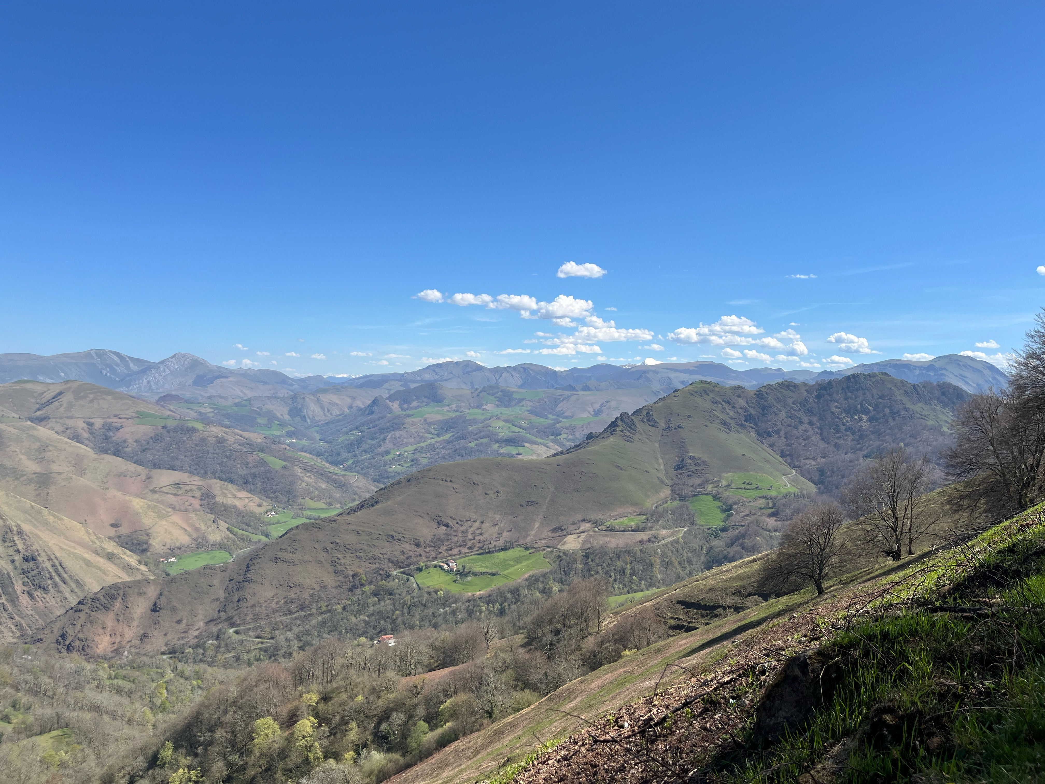

This idea has been living rent-free in my old brain for some long time. It’s about walking over the Pyrenees from France into Spain. It’s the most popular starting point for the Camino de Santiago. Thousands of Pilgrims set out every year from Saint-Jean-Pied-de-Port in France, over the mountains and on to Santiago de Compostela in Spain. It takes about six weeks. My intention is to finish at Pamplona just a few days away. I have already walked the Portuguese Camino to Santiago and I have the certificate hanging on my wall.

You are warned not to do it in winter; many have tried and some of them have died on the trail. And high summer is a different challenge: the young athletes, who number in the hundreds every day, charge on to the next refugio and it’s full before the old people can get there. My flight reservation to Paris is for April 1st which coincidentally or not happens to be April Fool’s Day.
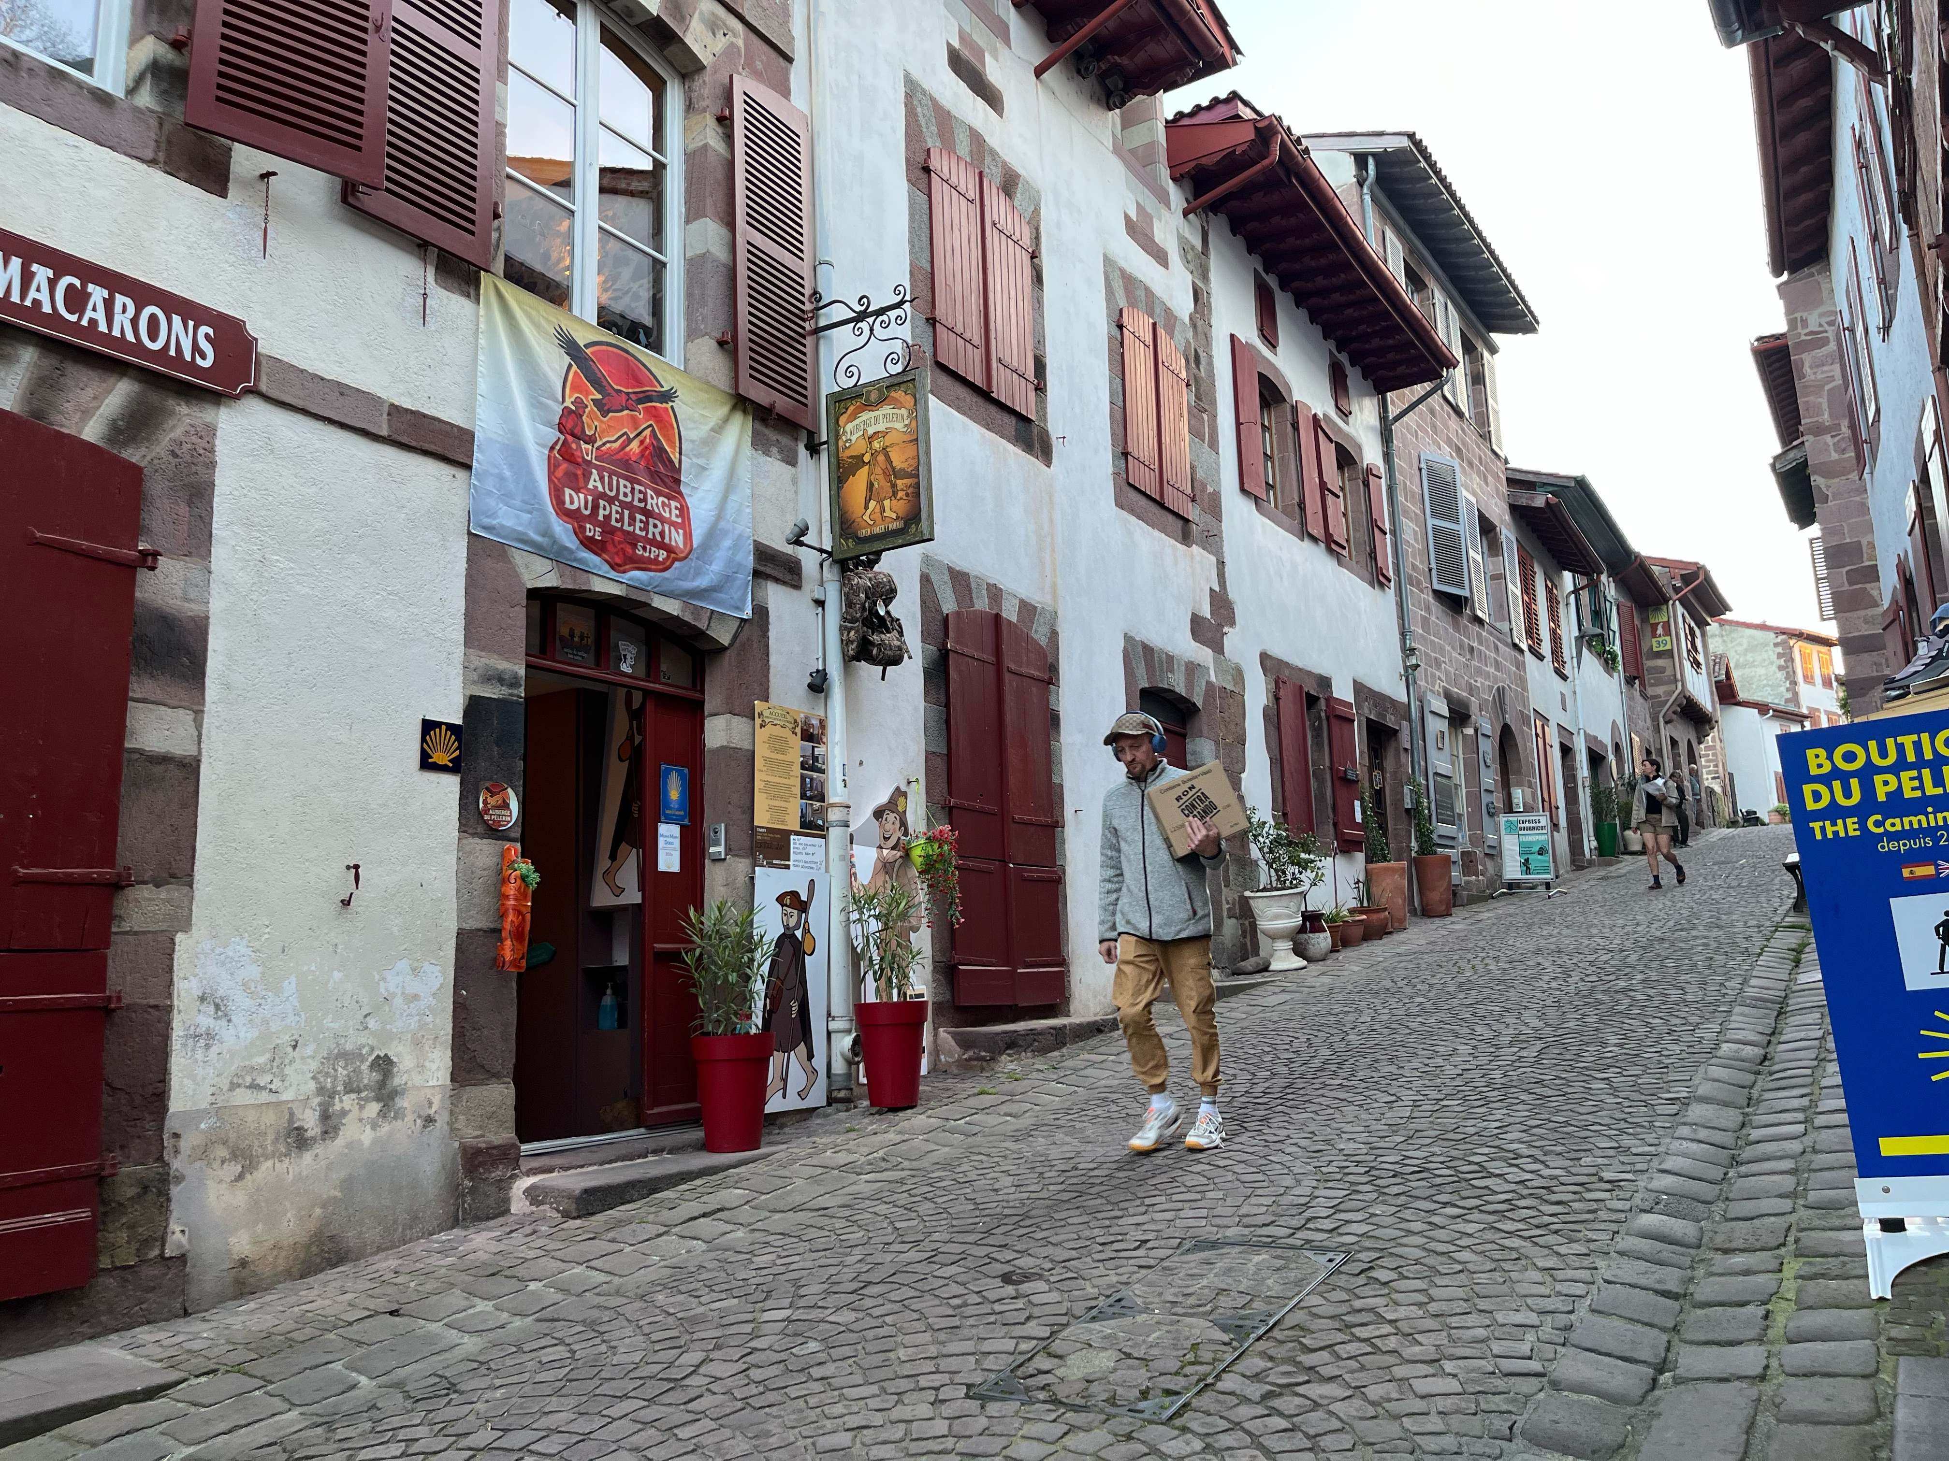

Saint Jean Pied de Port is a small town surrounded by big stone walls which
served as protection before the discovery of gun powder. Everything is up
the hill or down the hill in SJPDP, rarely on the level. It’s very well set up with
hotels, dormitories, restaurants and shops offering anything that the pilgrim
forgot to bring along.
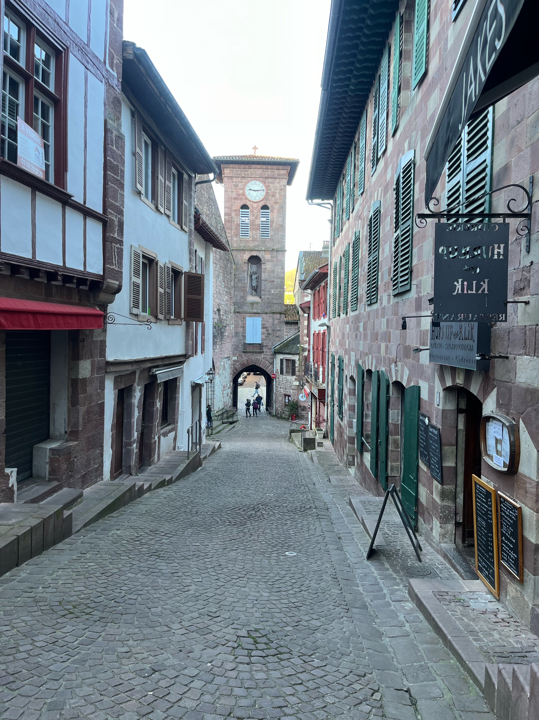
At the bottom of rue de la Citadelle you pass through a stone gate, cross the drawbridge and start walking uphill. From here on it will be all uphill until the Col de Lepoeder which is 1300 metres higher. Yes, there are some brief levelled sections and even some downhill paths which only add to the next uphill.

The weather is pleasantly warm and sunny and the forecast shows no change in the coming days.
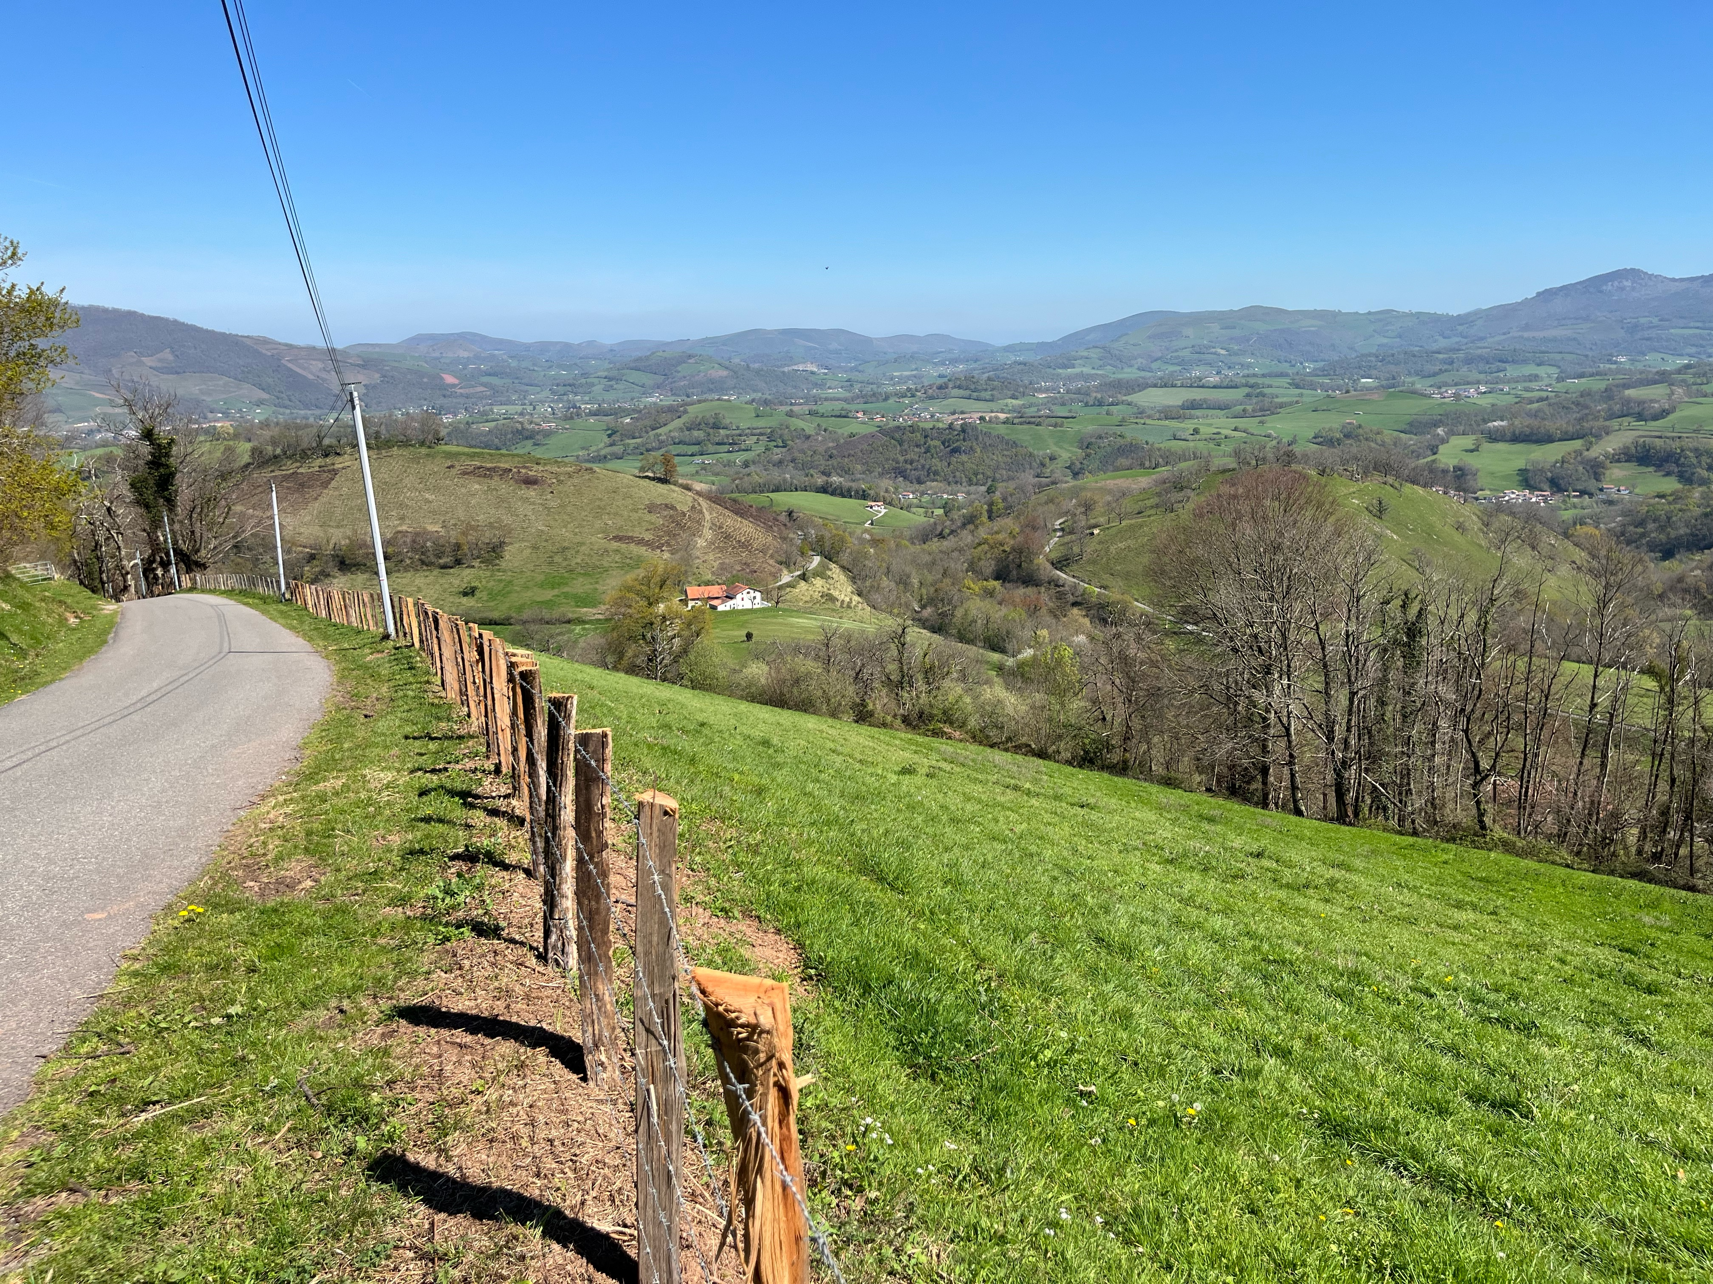

At the lower elevations, the Camino is a paved road, but with very little traffic. The fields are dotted with grazing animals: sheep, cattle and horses. So far, a pleasant walk, though all uphill. I’m in no hurry because I’m planning to stop for the night at Orisson which is less than halfway to the guidebook’s proposed stop at Roncesvalles.
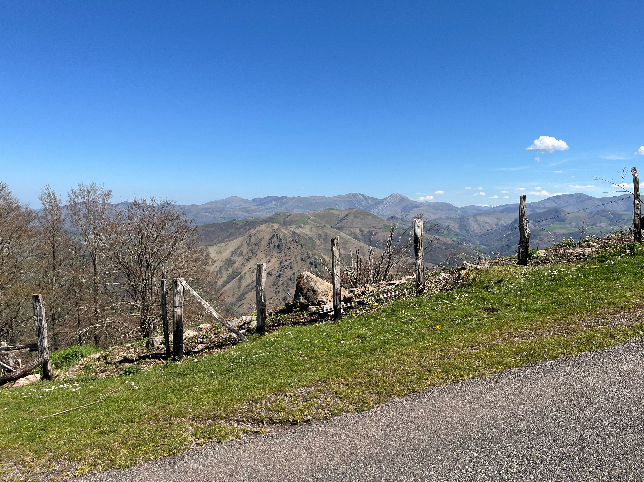
At the higher elevations, the green fields are all gone; the day remains bright and beautiful but knock-me-down winds are a new feature.
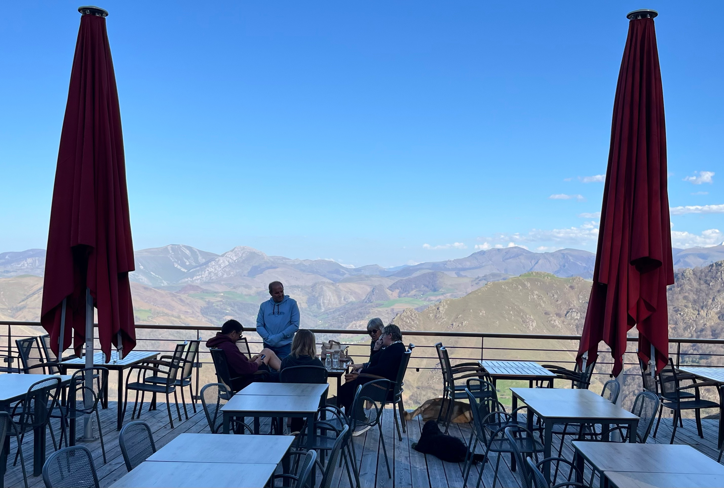

Orisson is uncrowded, as the young athletes have gone on to Roncesvalles. The mountains are lit up by the setting sun but our terrace is shaded by a hill.

I have reached the limit of my physical powers here; let the youngsters go on to Roncesvalles; I’m done. At my age (85) I’m happy to accept the offer of a supper, a bed, a breakfast
And a small lunch to take on the trail tomorrow.
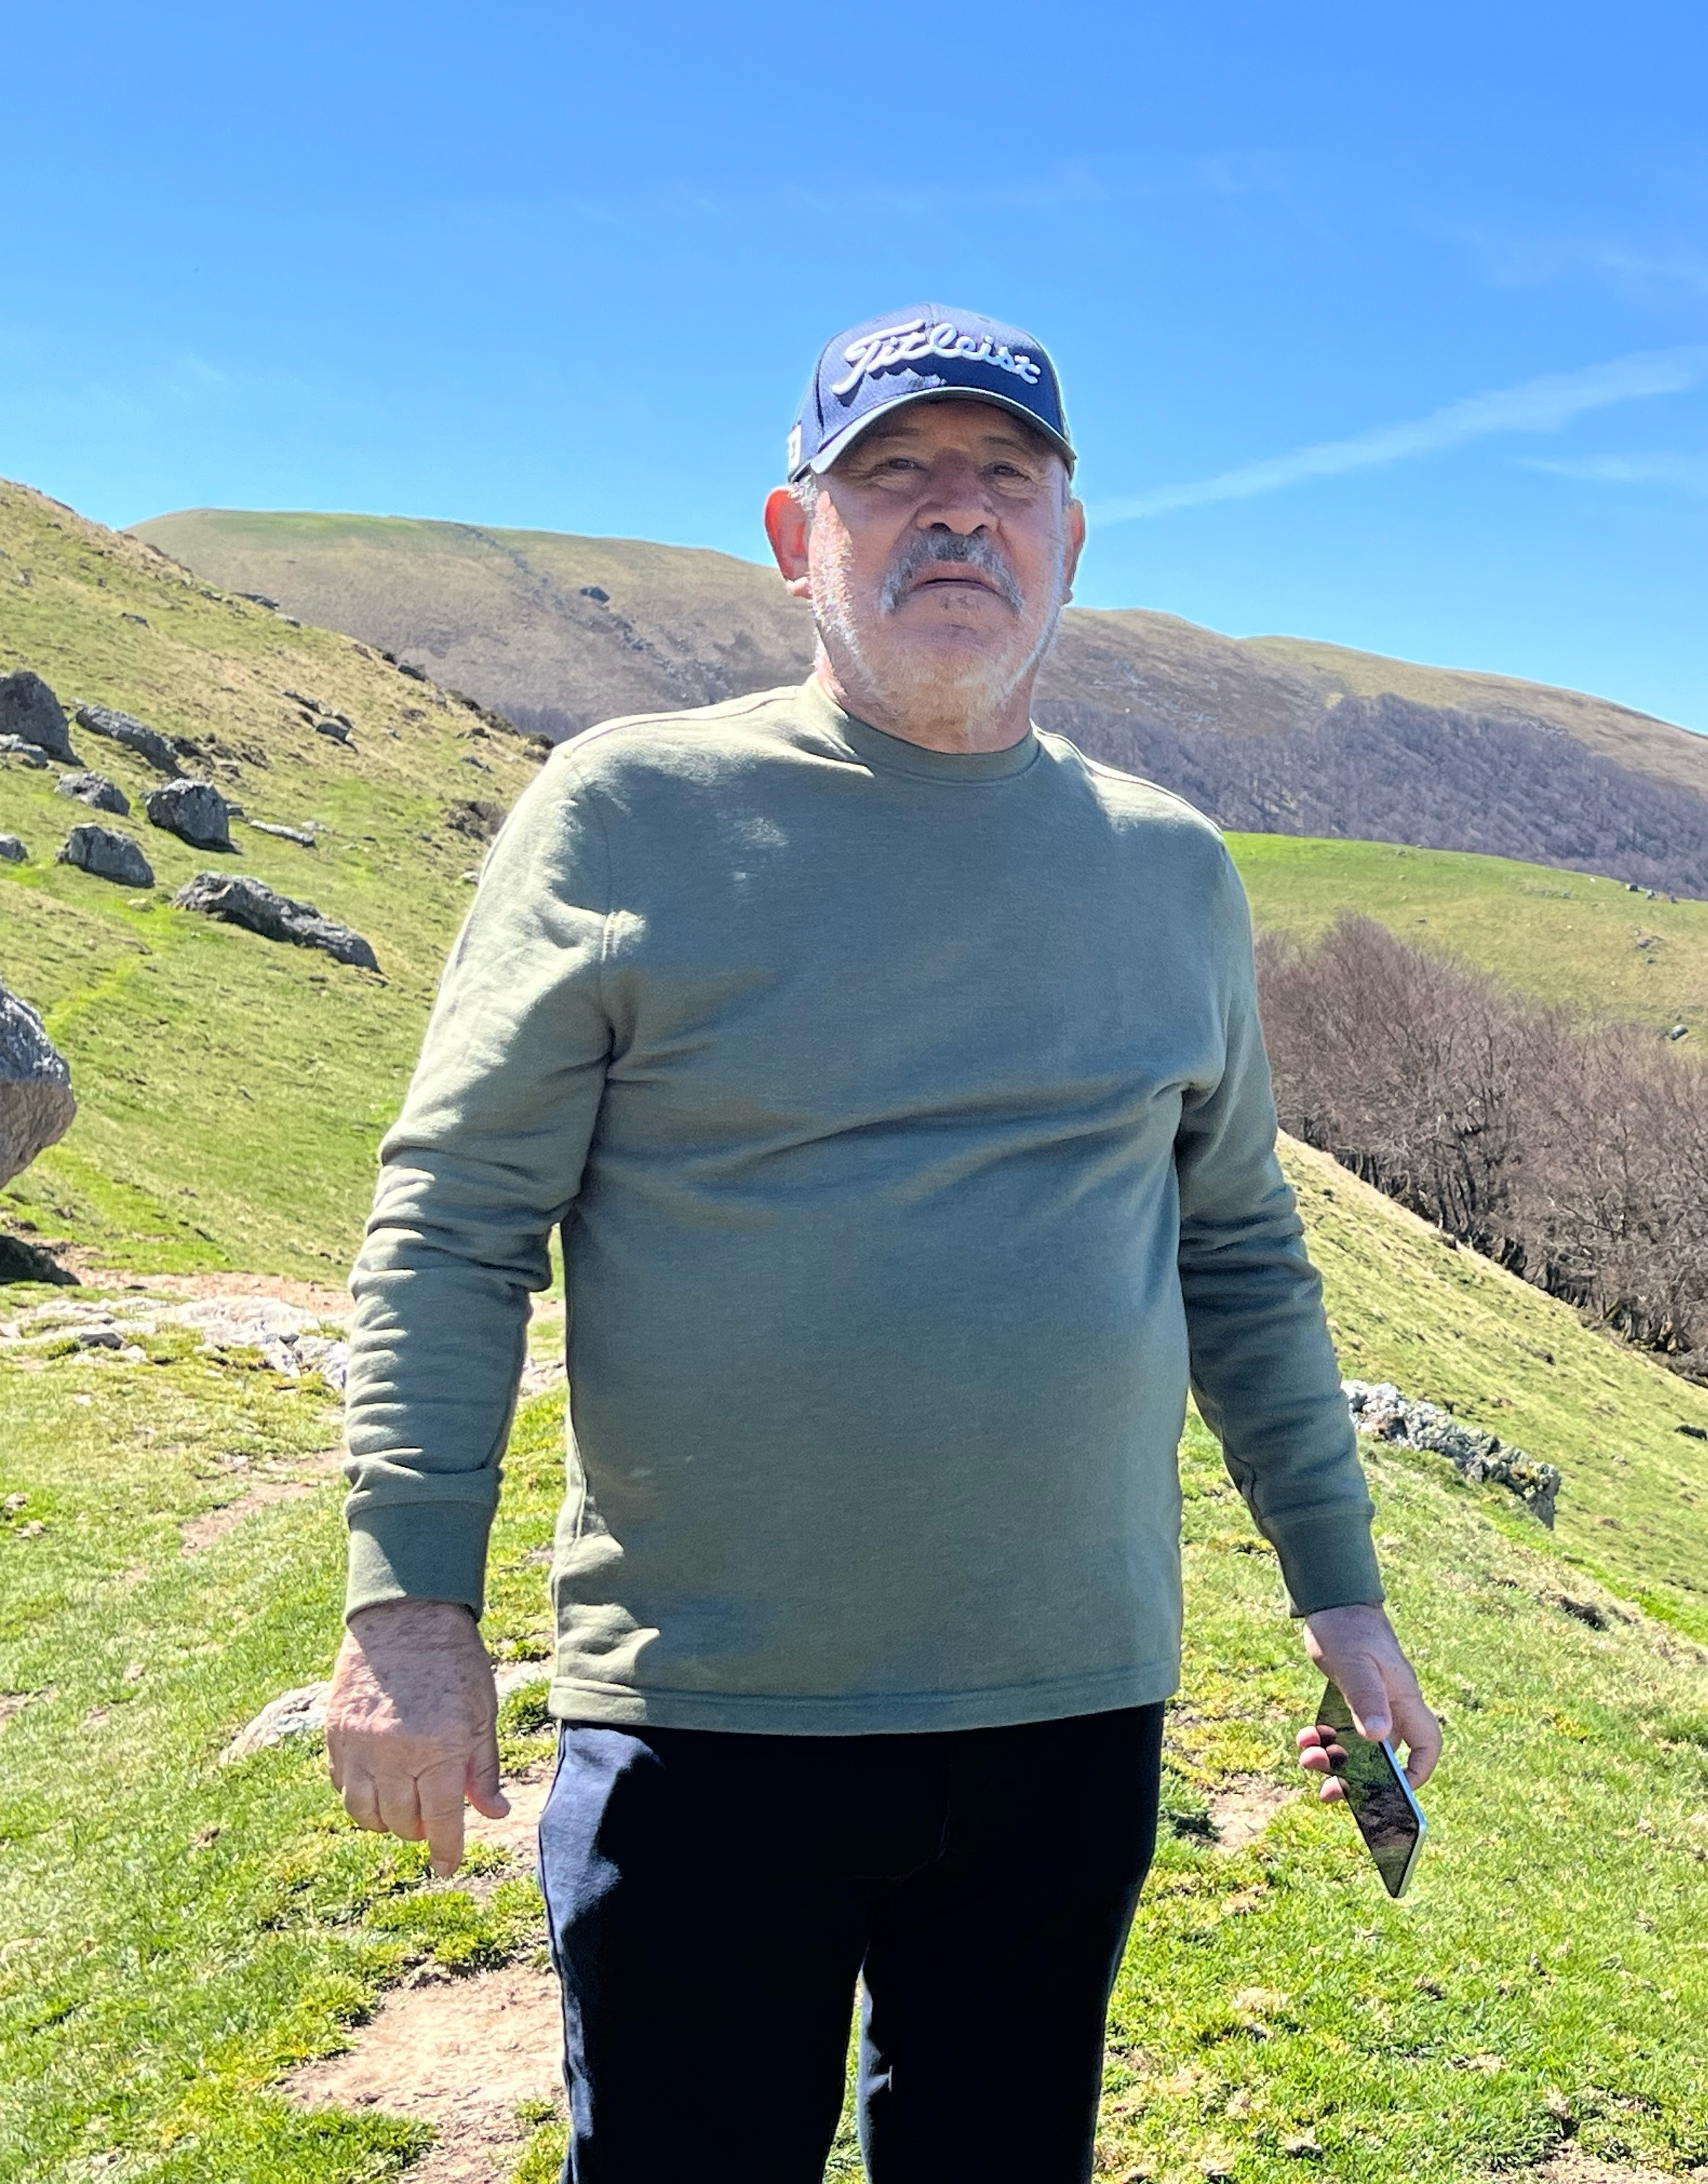
As I step out in the morning, there’s a long table with a group of pilgrims; one guy calls out to me: “That guy there, he says he wants to walk with you!” He points to the guy.

So, I sit down and meet Luis. He’s 67, a retired Phys Ed teacher from Mexico. He is, of course, Hispano-hablante, can manage a few words in English and zero French. OK, I have a functional level in Spanish and I would be happy to work on Spanish conversation.
We walk out together.

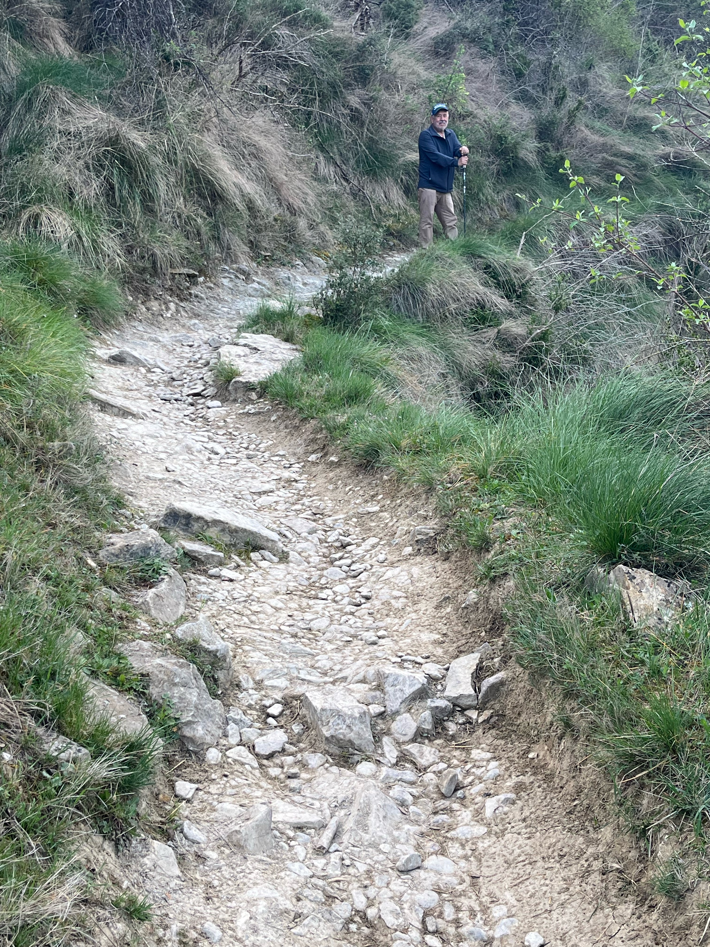
Some parts of the Camino are difficult and full of tripping hazards.
Both Luis and I have had a fall. No injuries.
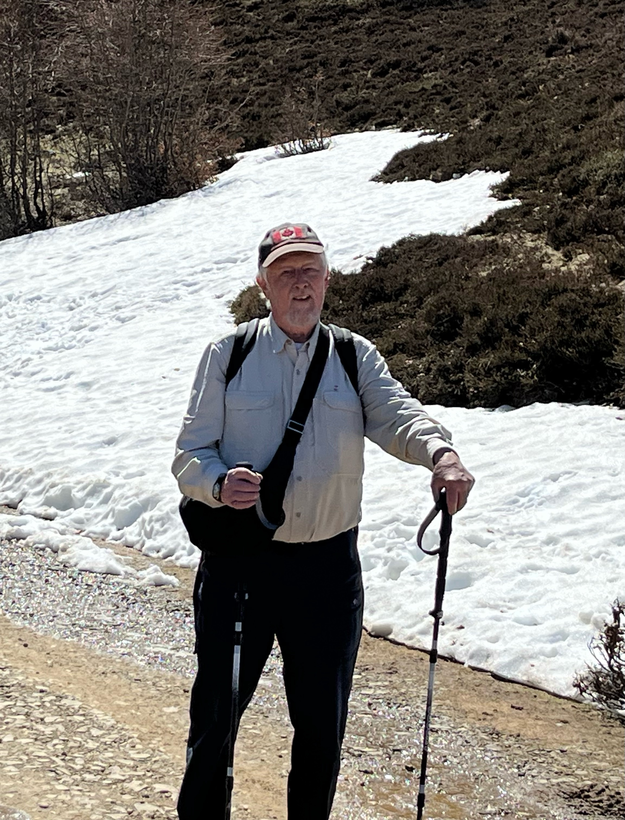
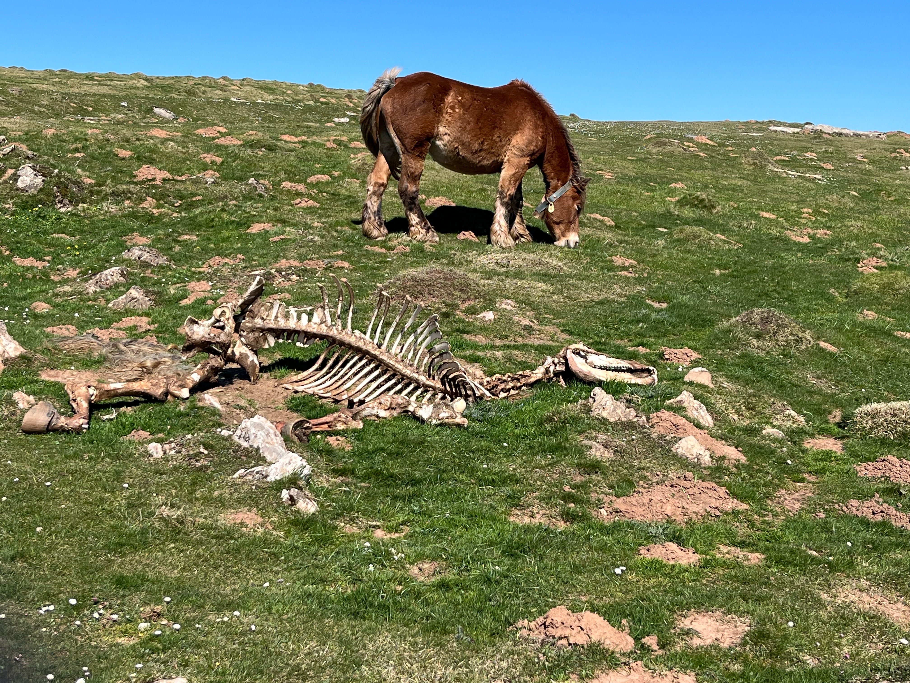
Approaching Roncesvalles there is a steep hill going down, a vertical 400 metres, a mix of huge boulders and rolling loose gravel. All this is very hard on the legs; I can’t imagine doing this walk all in one day as it’s presented in the pilgrim guide book.

I’ve had an assumption that I may well be the oldest pilgrim on the Camino, but in the Monastery of Roncesvalles I meet this man from Korea, He’s a year older than I and his intention is to walk all the way to Santiago de Compostela.
Type to enter text
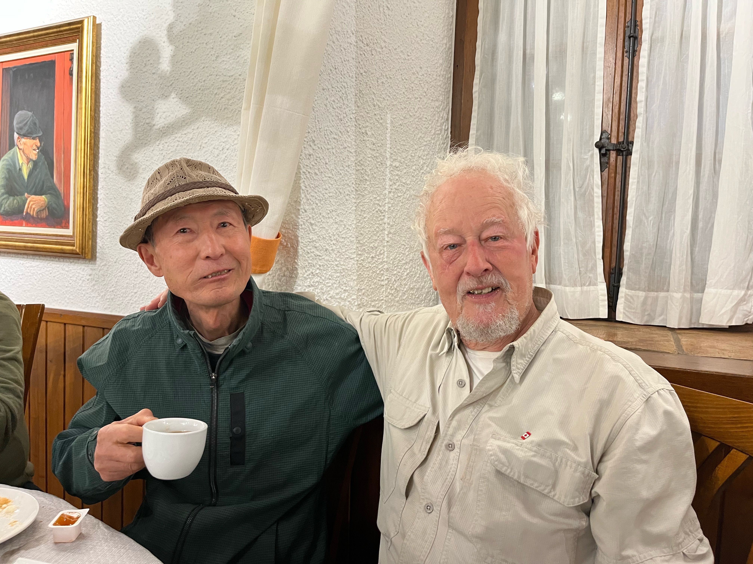
Approaching Roncesvalles there is a steep hill going down, a vertical 400 metres,
A mix of huge boulders and rolling loose gravel. All this is veery hard on the legs; I can’t imagine doing this walk all in one day was it’s presented ion the Camino guide book.

I’ve had an assumption that I may well be the oldest pilgrim on the Camino, but in the monastery of Roncesvalles I meet this man from Korea.
He’s a year older than I and his intention is to walk all the way to Santiago.
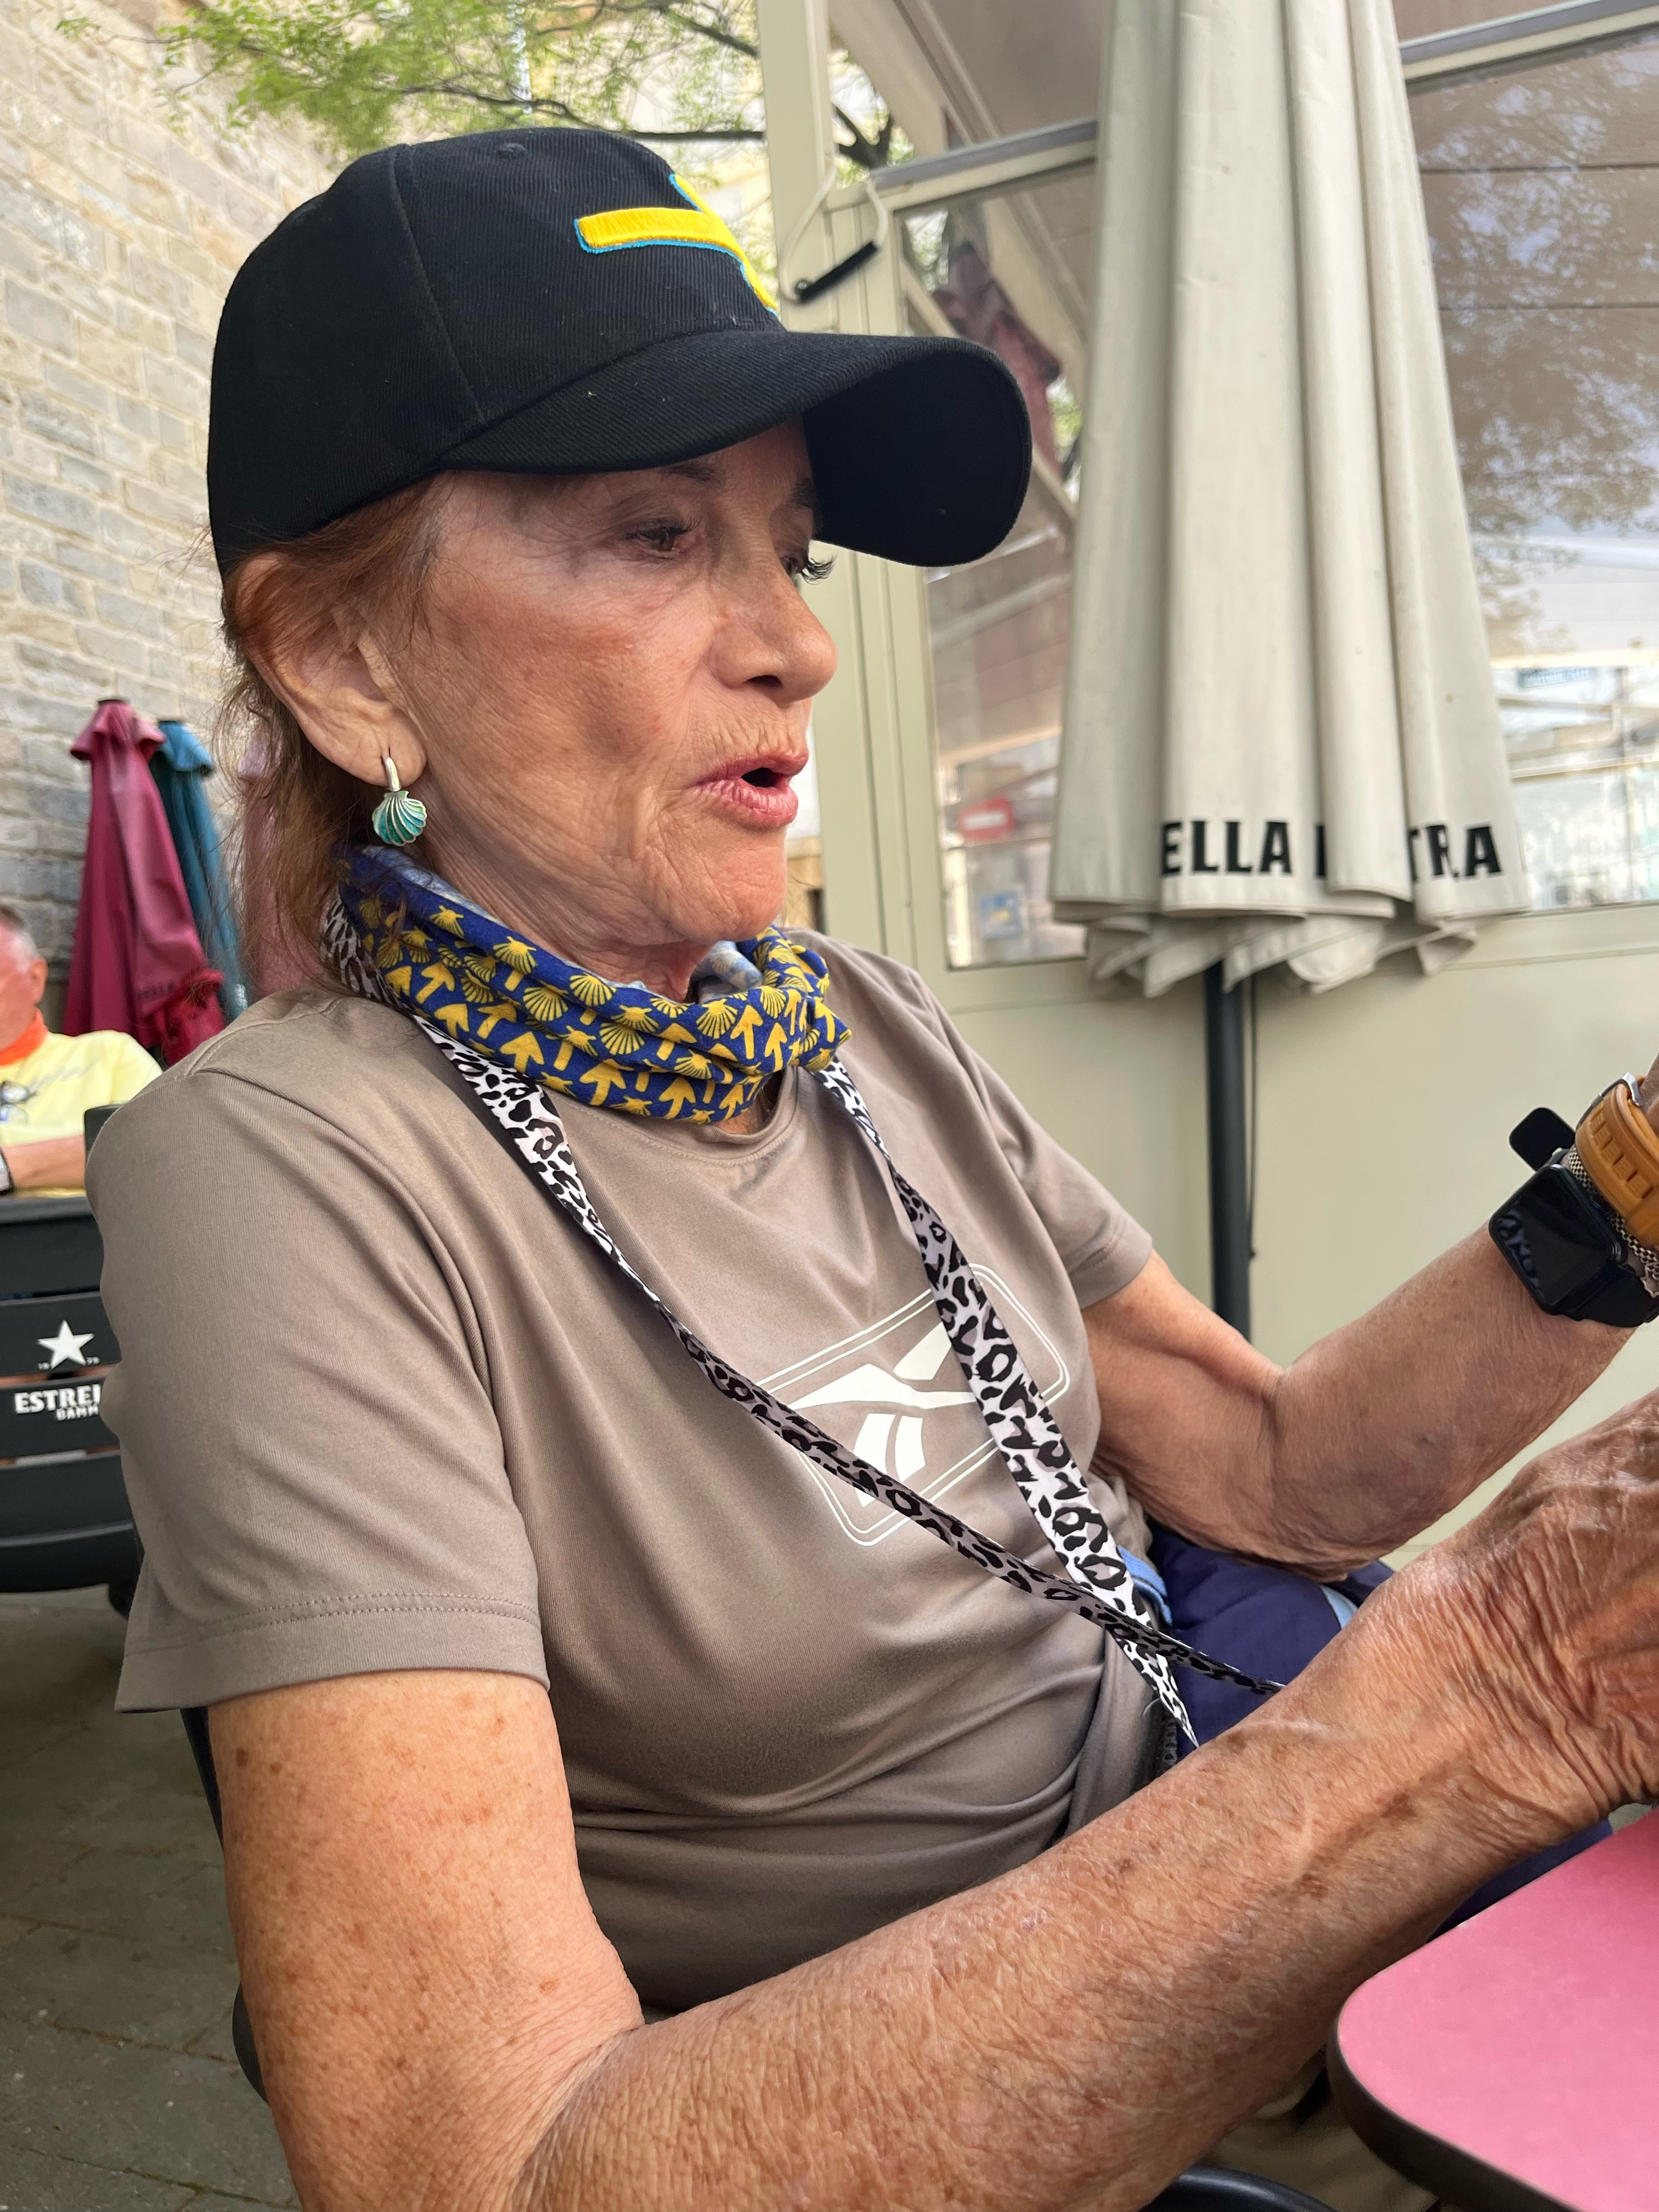
Onward to Viscarreta, a rather short day of 12 kilometres. In the hostel we meet Michelle, actor, rancher and adventurer from Idaho. After supper we ask for another carafe of wine and the house presents a bottle, gratis. Michelle and I pass an evening of lively conversation.
The bridge at Zubiri is called Puente de Rabia, based on a dubious legend that any animal could be cured of rabies by walking it three times around the central pier.
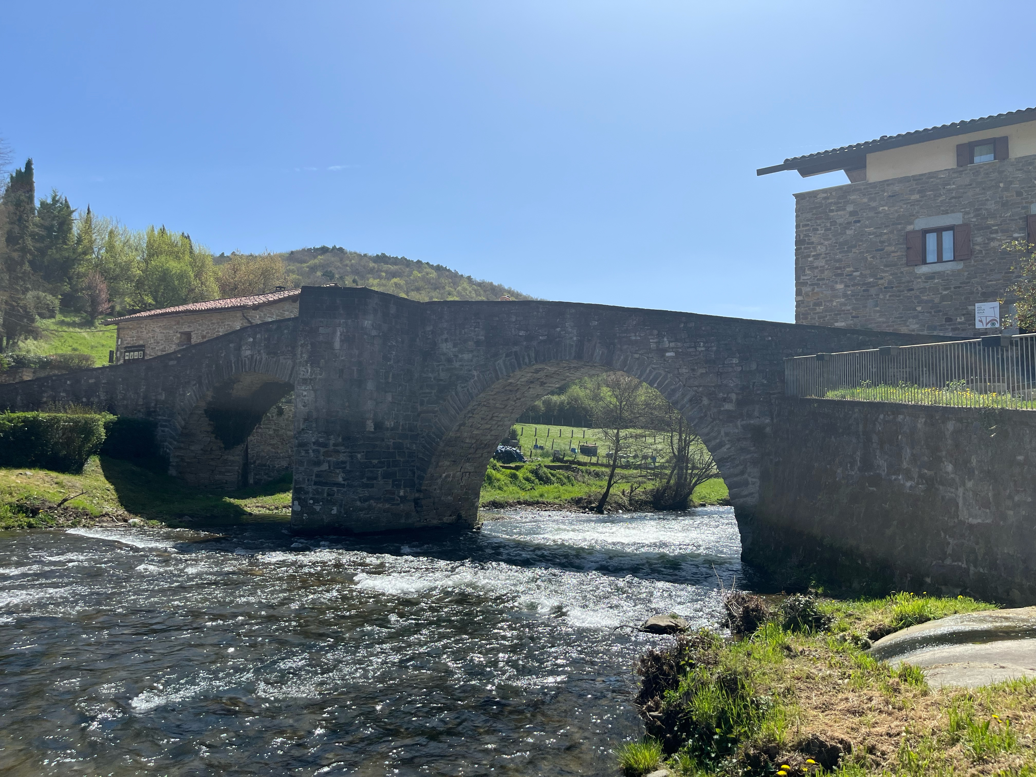
This is a small city that has a university; think of Kingston Ontario. There isn’t a lot of open space in these ancient cities, so the young people have their salon in the streets. The picture is a Friday evening in central Pamplona.

Saturday, I was ready to move on, to return to Paris which is always my home base in Europe. I found a bus that brought me back to Saint Jean. From there, I could find nothing going anytime soon. So, I went to a transportation mode that has served me very well over many years. I walked out to the edge of town and put out my thumb for a ride.

My ride took me to the train station in Bayonne where a TGV
(Train Grande Vitesse) runs directly to Paris Gare Montparnasse.
It’s a half hour walk to my garret room in the Latin Quarter.

The Bridge at Zubiri is called Puente dec Rabia, based on a dubious legend that any animal could be cured of rabies by walking it three times around the central pier.
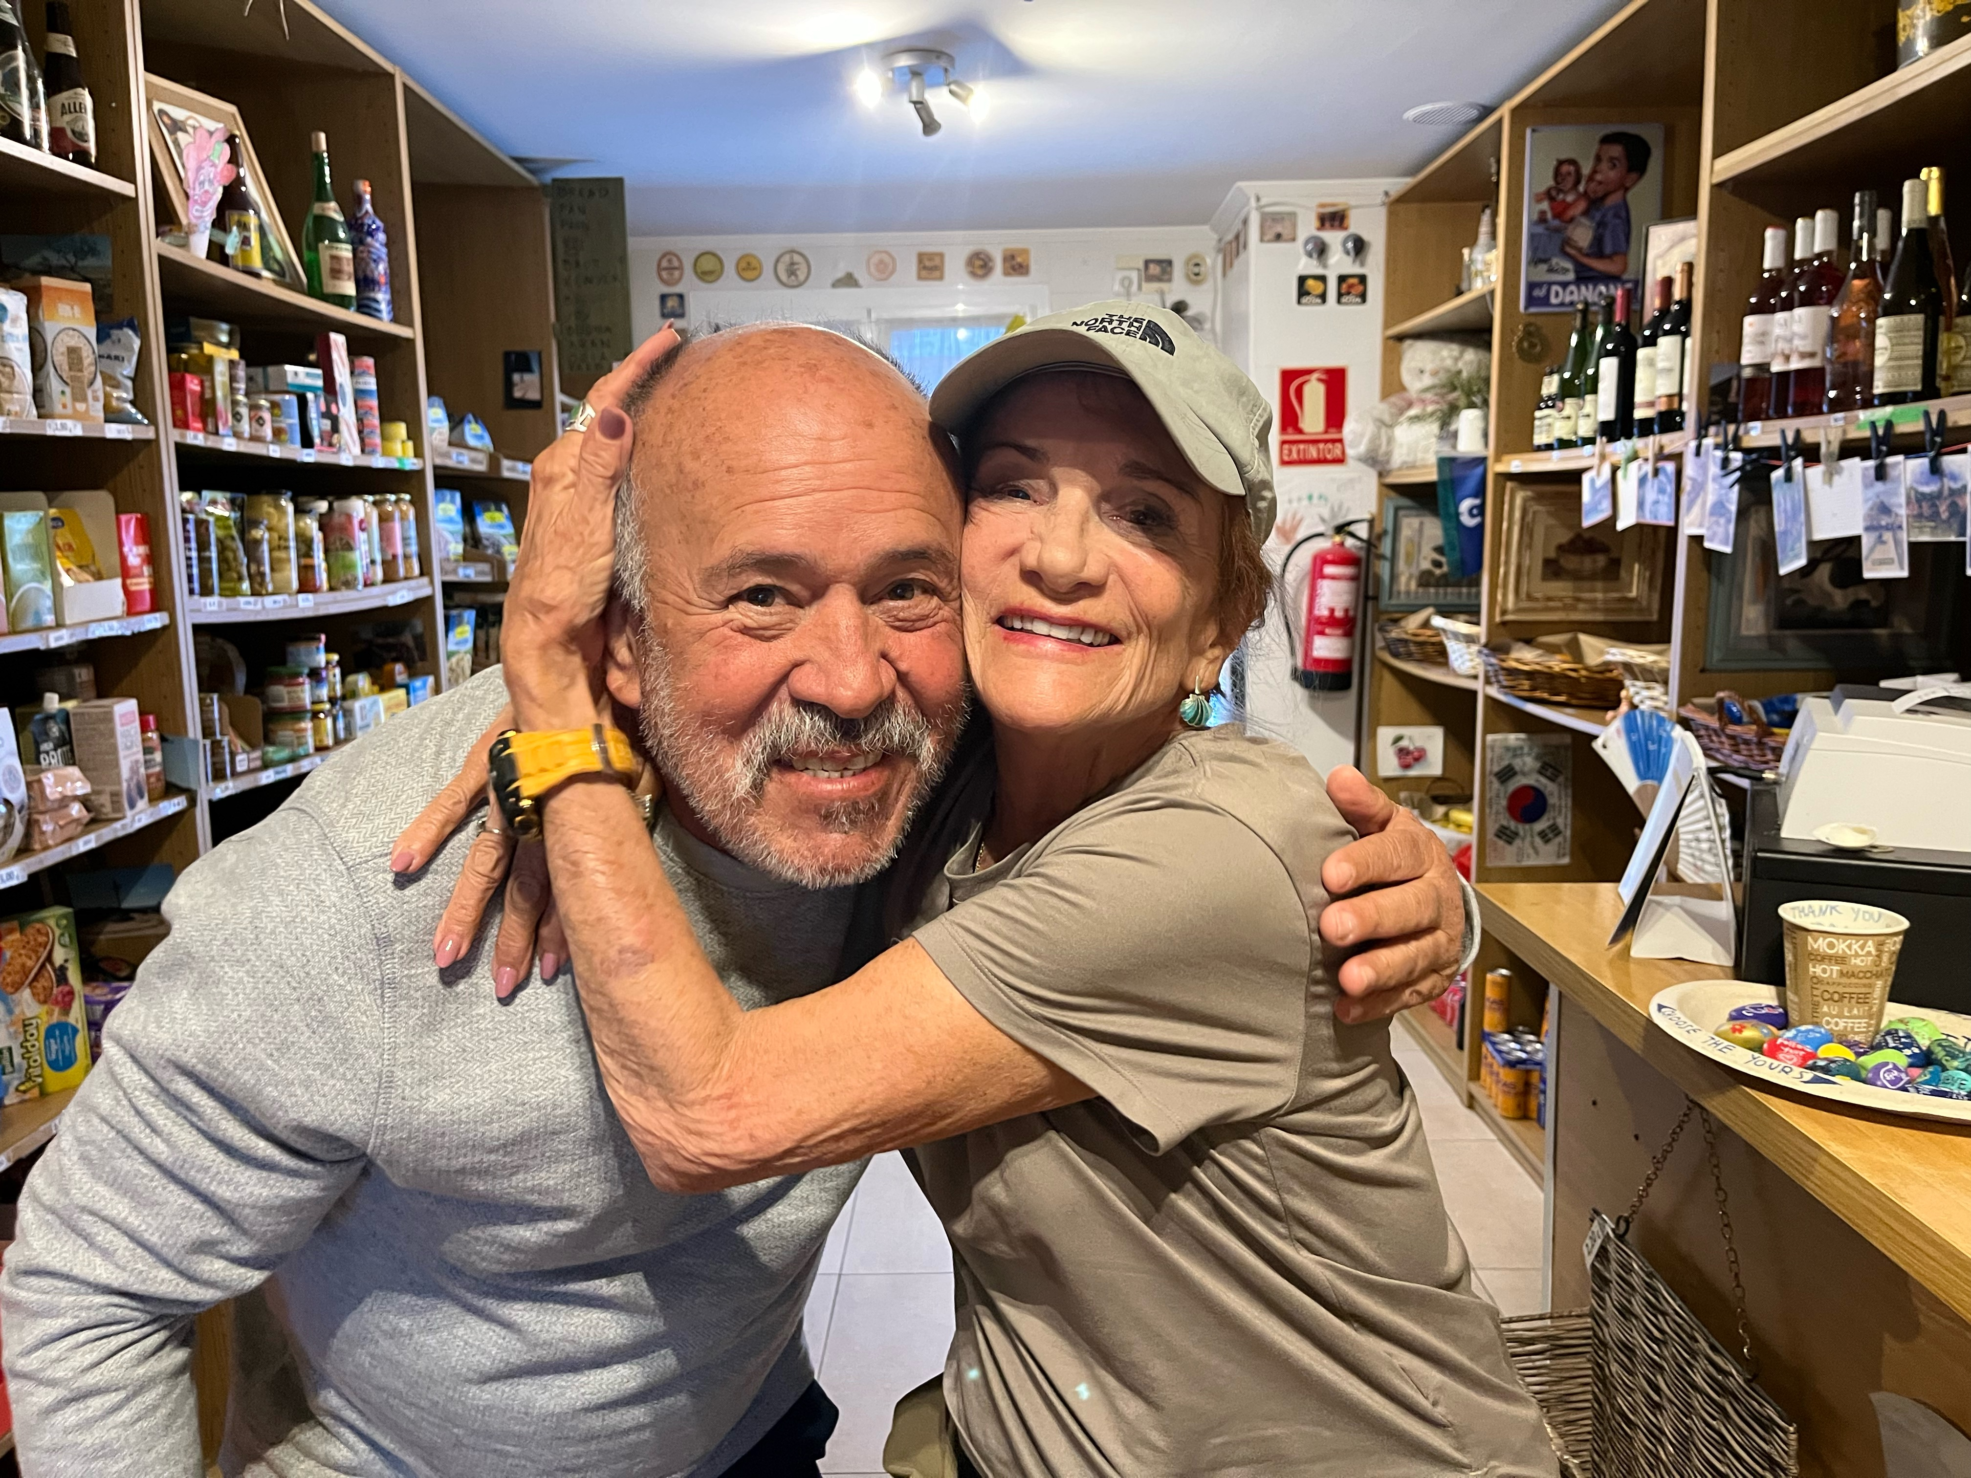
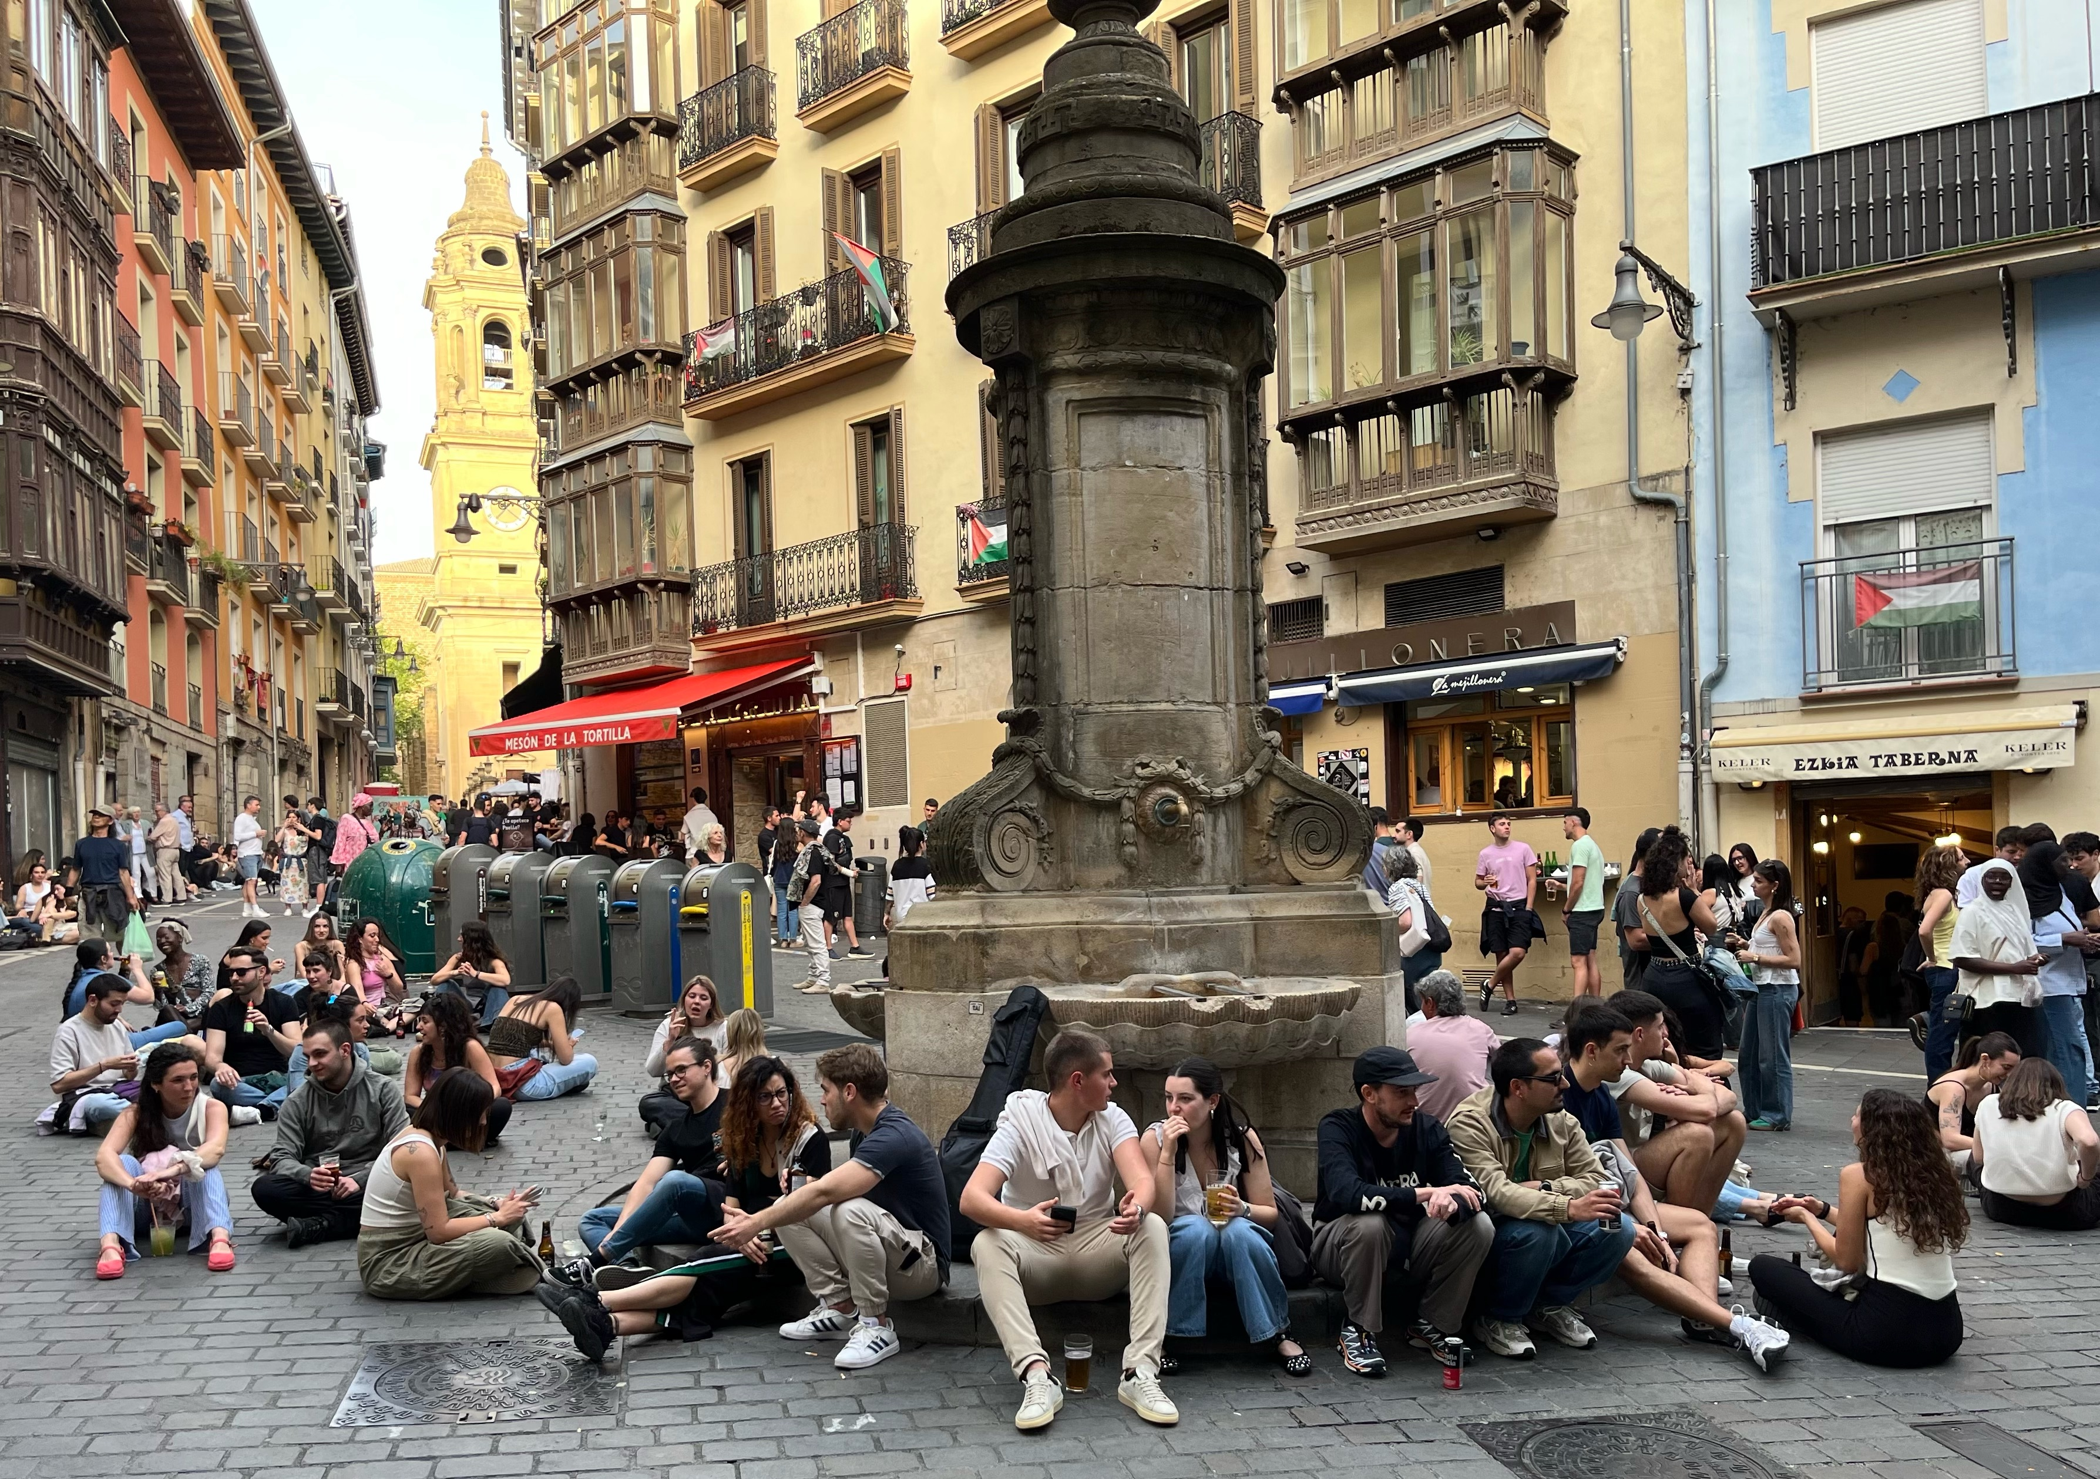
We enter the walled city of Pamplona, the end of my Camino at least for now. Luis will carry on to Santiago in the morning.

This is a small city that has a university; think of Kingston Ontario. There isn’t a lot of open space in these ancient cities, so the young people have their salon in the streets. The picture is a Friday evening in central Pamplona.

Saturday, I was ready to move on, to return to Paris which is always my home base in Europe. I found a bus that brought me back to Saint Jean. From there, I could find nothing going anytime soon. So, I went to a transportation mode that has served me very well over many years. I walked out to the edge of town and put out my thumb for a ride.

My ride took me to the train station in Bayonne where a TGV
(Train Grande Vitesse) runs directly to Paris Gare Montparnasse.
It’s a half hour walk to my garret room in the Latin Quarter.

Type to enter text
This is a small city that has a university; think of Kingston Ontario. There isn’t a lot of open space in these ancient cities, so the young people have their salon in the streets. The picture is a Friday evening in central Pamplona

Saturday I was ready to move on, to return to Paris which is always my home base in Europe. I found a bus that took me back to Saint Jean. From there I could find nothing going anywhere any time soon. So I went to a transportation mode that has served me very well over many years. I walked out to the edge of town and put my thumb out for a ride.

